**Droplet Evaporation on Hot Microstructured Superhydrophobic Surfaces:**

**Analysis of Evaporation from Droplet Cap and Base Surfaces**

Wenge Huang a †, Xukun He a †, Yahua Liu d, Jiangtao Cheng a, b, c, *

a Department of Mechanical Engineering, Virginia Tech, Blacksburg, VA 24061, USA

b Macromolecules Innovation Institute, Virginia Tech, Blacksburg, VA 24061, USA

c Center for Soft Matter and Biological Physics, Virginia Tech, Blacksburg, VA 24061, USA

d Key Laboratory for Non-traditional Machining Technology of Ministry of Education, Dalian University of Technology, Dalian 116024, China

*Corresponding author. E-mail: [chengjt@vt.edu](mailto:chengjt@vt.edu);

**Abstract**

In this study, sessile droplet evaporation on hot micro-structured superhydrophobic surfaces is experimentally and theoretically investigated and, for the first time, two distinguished components of heat and mass transfer, i.e., from the droplet cap surface and the base surface, during the droplet evaporation are systematically studied. Water droplets with volume of 4 μL are placed on silicon-based micropillar substrates with constant temperature varying from 40 °C to 120 °C. A comprehensive thermal circuit model is developed to analyze the effects of micropillars and substrate temperature on the sessile droplet evaporation. Droplet cap surface temperatures are predicted, and match well with the experimental results for droplet evaporation on substrates heated at 40 °C, 60 °C and 80 °C. Evaporation rates from the droplet cap surface and base surface are calculated and the decrease of evaporation rate from droplet base surface dominates the decrease of total evaporation rate in the constant contact radius mode and the decrease of evaporation rate from droplet cap surface is dominant in the constant contact angle mode. The effects of internal fluid motion of droplet are considered for droplet evaporation on substrate at 100 °C and 120 °C, and an effective thermal conductivity is employed as a correction factor for the thermal circuit model to consider the effect of convection heat transfer in the water droplet. Temperature differences between the droplet base and substrate base are calculated to be about 2 °C, 5 °C, 8 °C, 12.5 °C and 18 °C for the droplet evaporation on substrate heated at 40 °C, 60 °C, 80 °C, 100 °C, and 120 °C, respectively.

**Keywords:** Microstructured surfaces, superhydrophobic surfaces, droplet evaporation, thermal circuit analysis.

**1. Introduction**

Evaporation of sessile droplets is a ubiquitous natural phenomenon, which holds an important role in a variety of applications, including inkjet printing[1, 2], DNA mapping[3], spray cooling[4], and microparticle detection[5]. Meanwhile, sessile droplet evaporation is a complex phenomenon controlled by several interdependent factors, such as the droplet contact angle and contact radius[6], contact line motion[7-9], substrate structure[10-15], temperature[16-21] and the surrounding environment[22-24].

Since the seminal work of Picknett and Bexon in 1977[25], sessile droplet evaporation on smooth surface has been systematically analyzed, in which droplet evaporation was distinguished into three evaporation modes: (1) the constant contact radius (CCR) mode: the droplet contact line is pinned with constant contact radius while contact angle keeps decreasing. (2) the constant contact angle (CCA) mode: once the contact angle approaches the receding contact angle, the contact line keeps receding droplet with unchanged contact angle; (3) the mixed mode: both the contact radius and contact angle decrease near the end of evaporation. In several recent studies about the droplet evaporation on structured superhydrophobic surfaces, a special stick-slip mode[26] was observed, in which droplet contact line is moved by the pinning and depinning force alternately.

Several theoretical models have been proposed to predict the evaporation rate of sessile droplet. Also in the classical work of Picknett and Bexon[25], the sessile droplet evaporation in room temperature was firstly assumed to be driven by the vapor diffusion by ignoring the heat transfer and convective flow inside/outside the droplet. And the analytic evaporation rate could be obtained based on an analogy between the concentration field and the electrostatic field[27]. In the past two decades, this diffusion-driven model was extensively studied, which has been applied on modeling the evaporation of sessile droplet with the arbitrary contact angle in CCR mode or with slipping contact line in CCA mode. Comparing with the experimental data, the excellent accuracy of predicted evaporation rate confirm the validity of diffusion-driven model of sessile droplet evaporation not only on hydrophilic surfaces[28-30] but also on hydrophobic surfaces[21, 31].

However, when the model was employed on sessile droplet evaporation the superhydrophobic surfaces with microstructure[32], especially on heated superhydrophobic surfaces, an overestimation of evaporation rate was observed by Garimalla and Aldhaleai[33-35]. This deviation of the predicted evaporation rate should be the results of the evaporative cooling giving rise to a temperature reduction on the liquid-vapor interface, which is contradict with the pivotal assumption in classical diffusion-driven model that the temperature of the droplet surface is constant and same as the substrate temperature[28-30]. For instance, the maximum temperature mismatch ~ 20 °C between the droplet surface and the substrates was experimentally measured when the substrate was heated at 70 °C[16]. Furthermore, the availability of diffusion-driven model might become worse when the different wetting states of droplet on micro-structured surfaces, i.e., Cassie state and Wenzel state are considered. For a sessile droplet evaporates in Cassie state, the existence of the air/vapor cavities between the droplet base and the microstructure would lead to two different components of droplet evaporation, i.e., from the liquid-vapor interface at (1) droplet cap and (2) the droplet base. However, the effect of this extra evaporative interface from the droplet base on sessile droplet evaporation on superhydrophobic surfaces was generally ignored in the majority previous works[33, 36, 37]. Indeed, in recent works of Wang and Kim[17, 38, 39], the non-negligible evaporation flux through vapor-liquid interface over the cavity has been experimentally confirmed on heated superhydrophobic surfaces, whereas these works are mainly focusing on the wetting or dynamics of evaporating droplet. Therefore, a systematic study about droplet evaporation on heated superhydrophobic surfaces by considering the comprehensive effect of multiple and discontinuous liquid-vapor interfaces at droplet base and droplet vapor is desired.

In this paper, the evaporation of water droplet on hot micro-structured superhydrophobic substrates is experimentally and theoretically investigate. The water droplets with volume of 4 μL are placed on the superhydrophobic substrates heated at 40 °C, 60, and 80 °C, respectively. The droplet is evaporated in Cassie state during the majority of evaporation time and transited into the Wenzel state at the very end of the evaporation. Based on a comprehensive thermal resistance analysis, a thermal circuit model has been developed to predict the droplet cap surface temperature and to calculate the evaporation rate from the droplet cap surface and base surface. An evaporation ratio 𝜑 defined as the ratio of evaporation rate from the droplet base surface and the total evaporation rate is analyzed in CCR mode and CCA mode, respectively. And we find that the droplet surface temperatures predicted by the thermal circuit model match well with the experimental results. Both the evaporation rates from droplet cap and base surfaces decrease during the evaporation. The decrease of the evaporation rate from droplet base surface dominates the decrease of total evaporation rate in the CCR mode and the decrease of evaporation rate from the droplet cap surface is dominant in the CCA mode. The evaporation ratio 𝜑 decreases in the CCR mode and increases approaches the end of CCA mode. Then the substrate is further heated from 80 °C to 120 °C until when a small rise of the substrate temperature will lead to the boiling of the droplet. Deviation between the experimental measured droplet surface temperature and the predicted surface temperature is observed for droplet evaporation at such high temperature substrates because of the internal fluid motion of the water droplet. An effective thermal conductivity is employed as a correction factor for the thermal circuit model to consider the effect of convection heat transfer in the water droplet. The average temperatures of droplet base surface are calculated and the temperature differences between droplet base and substrate base are about 12.5 °C and 18 °C for droplet evaporation on substrates heated at 100 °C and 120 °C, which explains the nonboiling of droplets on the superheated substrates. This study could deepen our understanding of the process for droplet evaporation on hot microstructured superhydrophobic surfaces and provide us a potential way to control the sessile droplet evaporation on non-wetting surfaces.

**2. Experimental methodology**

**2.1 Substrates**

Silicon-based substrates with square pattern micropillars were manufactured by standard contact photolithography process and deep reactive ion etching method[5, 40-42]. Three kinds of substrate with thickness of 1 mm and textured with cylindrical micropillar arrays with increasing micropillar periodicity (*P*) were used in this investigation. The geometry information of the substrates is listed in Table 1 and the scanning electron microscope (SEM) image of one substrate sample used in this study is shown in Fig. (1). All the substrates were conformally coated with silane (Trichloro (1H,1H,2H,2H-per fluorooctyl)-silane, Sigma-Aldrich) using standard chemical vapor deposition (CVD) process for superhydrophobicity[43]. Then the substrates were placed on a 100°C hot plate for 60 min backing. Water droplet exhibits a contact angle about 155° on all the substrates. To mitigate the sample edges effect on the droplet evaporation process, substrate samples were cut into square pieces with the dimension of 2 cm 2 cm and water droplets were deposited on the center of the substrate.

**Table 1.** Micropillar diameter, periodicity and height of different sample substrates

|  |  |  |  |
| --- | --- | --- | --- |
| Substrate | Micropillar diameter D (μm) | Micropillar periodicity P (μm) | Micropillar height H (μm) |
| Sample 1 | 20 | 40 | 40 |
| Sample 2 | 20 | 50 | 40 |
| Sample 3 | 20 | 60 | 40 |

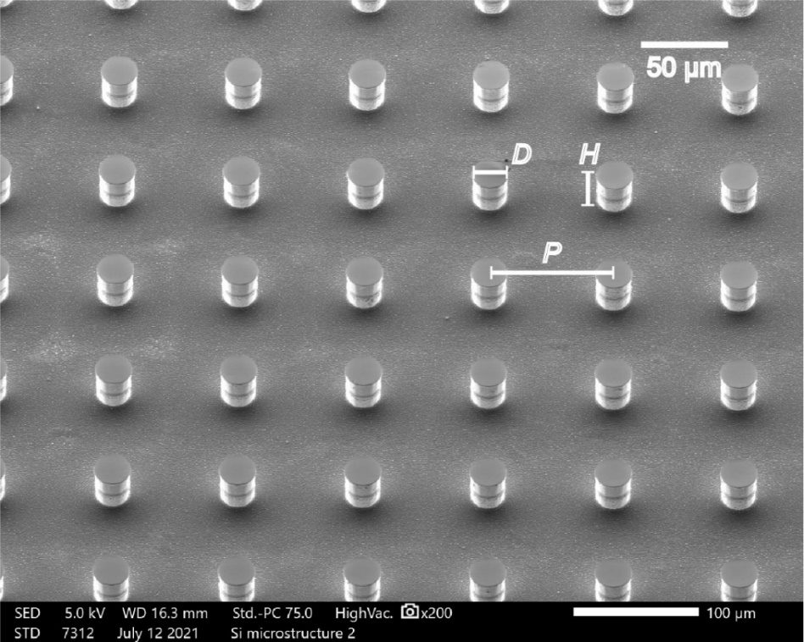

**Figure 1.** Scanning electron micrograph of the tested sample used in this investigation.

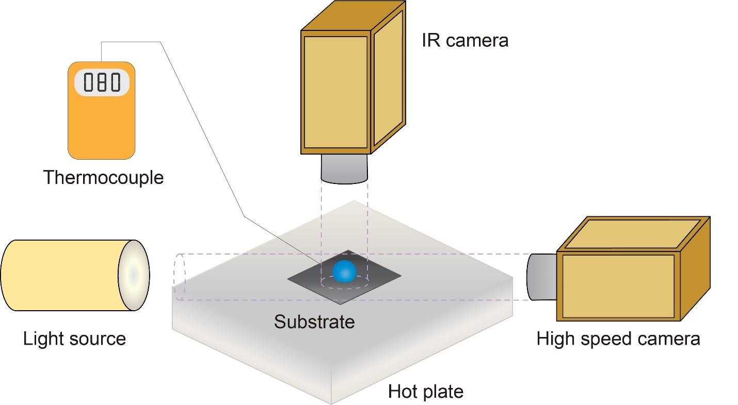

**Figure 2.** Schematic diagram of the experimental setup including cameras, substrate, hot plate and thermocouple.

**2.2 Experimental setup**

Fig. 2 shows the schematic diagram of the experimental setup. In this study, deionized (DI) water (Type 1, >18 MΩ cm resistivity) was used as the liquid and a DI water droplet with volume of 4 ± 0.1 μL generated by a syringe pump (EW-74905, Cole-Parmer Corporation) was gently dispensed on the center of the heated superhydrophobic micro-structured substrate for evaporation. Five trials were carried out for each droplet evaporation process to make sure the evaporation process is stable and repeatable. Because of the small volume, the shape of the water droplet resembled a spherical cap. The substrates were affixed on a hot plate and a K-type thermocouple with 0.5 °C uncertainty was used to test the base temperature of the substrate during the experiment. The base temperature of the substrate was maintained at a constant by the hot plate ranging from 40 °C to 120 °C beyond which a small temperature increase would lead to the onset of boiling of the experimental droplet deposited on the substrate. Two cameras parallel and normal to the substrate were used to record the evaporation process of the droplets. A calibrated infrared (IR) camera (FILR A5) was fixed on the top of the droplet and normal to the substrate to measure the surface temperature of the droplet. Because of the superhydrophobicity of the substrate, droplet on the substrate exhibited large contact angle and only the upper hemispherical surface of the droplet can be focused by the IR camera. Regardless the effects of droplet flow on the temperature distribution of the droplet surface, the temperature measured by the IR camera was understood as the average temperature of the droplet upper hemispherical surface. A high-speed camera integrated with a contact angle measurement system (Theta Lite, OneAttension Corporation) was used to measure the geometry of the droplet through time. The high-speed camera was fixed parallel to the substrate to capture the images of the droplet. The droplet is assumed to be in an axisymmetric spherical cap shape. Based on the snapshots, the water droplet was divided into layers and the local height and diameter of the water layer was tested from the images. The volume of the droplet was calculated by integrating the discrete water layers. With the snapshots obtained by the high-speed camera, the transient droplet volume, contact angle, contact radius and droplet height were collected. The ambient temperature and relative humidity were °C and , respectively.

**3.** **Experimental model**

**3.1 Wetting state**

Droplets exhibited different wetting states on the microstructured substrate during the evaporation. It is observed that there are specific air/vapor cavities underneath the droplet during majority duration of the evaporation process, which means the droplet was in Cassie state. At the very end of the evaporation, water liquid filled the cavities underneath the droplet and the droplet was in Wenzel state during this time. The snapshots of the water droplet during the evaporation are shown in the supplementary information. Though droplet exhibited two wetting states during the evaporation, the droplet was in Cassie state during most of the evaporation process. We mainly focus on the evaporation process of droplet in the Cassie state and the thermal circuit model developed is based on Cassie state droplets in this investigation.

**3.2 Energy balance model**

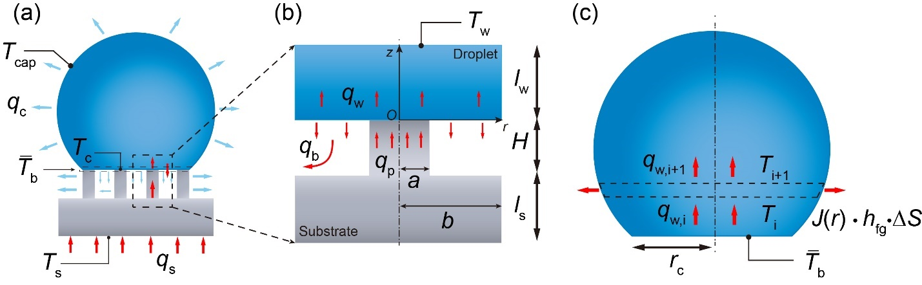

**Figure 3.** (a) Diagram of droplet evaporation on hot superhydrophobic microstructured substrate. (b) Diagram of heat transfer from micropillar into droplet base surface. (c) Diagram of heat transfer insider the water droplet.

Heat will transfer from the hot plate through the substrate into the sessile droplet due to the temperature difference between the hot substate base and droplet surface as shown in Fig. 3 (a). When the droplet is deposited on the hot substrate, heat will transfer from the hot plate through the substrate into the droplet. This heat transfer process will result in the temperature increase of the droplet and accelerate the heat and mass transfer between the droplet and the ambient air. The energy balance equation of the droplet can be derived as:

(1)

where is the overall transfer rate from the substrate to droplet; is the energy transfer rate for the water temperature increase; is the convective heat transfer rate for the convection heat transfer between the water droplet and the ambient air; is the heat transfer rate for the radiation from water droplet to the ambient air; is the heat transfer rate of the evaporation.

(2)

(3)

(4)

(5)

where , , , V and are the specific heat capacity, density, surface temperature, volume and latent heat of the droplet water, respectively; is the emissivity of the water droplet interface and is the Stefan-Boltzmann constant; *S* is the liquid-vapor interface area and is the natural convection heat transfer coefficient of the ambient air.

Because of the high efficiency of phase change heat transfer process, the heat transfer rate induced by evaporation is dominant over the heat transfer rate of the other three types. Thus, the overall heat transferred from the substrate to the water droplet can be estimated as the heat released from the droplet into the ambient by evaporation. The energy balance equation can be rewritten as:

(6)

**3.3 Evaporation from droplet base surface**

Evaporation of droplet happens at the liquid-vapor interface. For Cassie state droplet on microstructure substrate, there are air/vapor cavities between the droplet base and the substrate. Different from droplet evaporation on smooth surface for which all the droplet base contacts with the solid substrate, only part of the droplet base contacts with the solid microstructure substrate for Cassie state droplet evaporation. The existence of liquid-vapor interface at the droplet base surface causes the happening of evaporation at droplet base surface. In previous studies of Cassie state droplet evaporation on microstructure surfaces at room temperature, the evaporation from droplet base surface is always neglected and only the evaporation from droplet cap surface is considered[36, 37]. It is reasonable to neglect the evaporation from droplet base surface for sessile evaporation at room temperature considering the relatively small liquid-vapor interface area and the high relative humidity in the air/vapor cavities. However, for Cassie state droplet evaporation on hot microstructure substrate, the temperature increase of the substrate will cause a direct temperature rise of the droplet base surface, which will makes the evaporation from the droplet base surface unneglectable. As a result, both the evaporation from the droplet cap surface and base surface should be taken into account as shown in Fig. 3 (a) for Cassie state droplet evaporation on hot micro-structured surfaces.

Because of the periodicity of the micropillar arrays, the heat transfer process in one-unit micropillar cell can represent the characteristic of the heat transfer process between the droplet base and substrate micropillars[17]. Thus, we focus on one unit cell of the micropillar and the heat transfer from one-unit micropillar cell into the droplet base surface is shown in Fig. 3 (b). A micropillar cell consists of one micropillar and one air/vapor cavity around the micropillar. In general, heat transfer from both the silicon substrate and the vapor cavity should be calculated. The thermal resistance of the vapor is much larger than the thermal resistance of the silicon micropillar due to the significant ratio between the thermal conductivity of silicon micropillars (100 Wm­-1K-1)[17] and water vapor (0.025 Wm­-1K-1)[38]. Therefore, it is reasonable to assume that heat primarily conducts from the micropillar to the water droplet whereas the vapor-solid interface of cavity boundary can be regarded as adiabatic.

As is mentioned before, heat transferred from the substrate is equal to that released to the ambient air. Thus, we can calculate the substrate heat transfer rate by obtaining the evaporation heat transfer rate of the water droplet based on the decreasing of droplet volume (Eq. 5). Thus, heat transfer rate in one unit cell could be calculated as:

(7)

where *N* is the number of the micropillar underneath the droplet which can be calculated by the ratio of droplet apparent contact area and unit cell area.

The thermal resistance of the silicon substrate per unit cell could be calculated as:

(8)

where is the thermal conductivity of silicon and  is the thickness of the silicon substrate excluding the height of micropillar.

Based on the energy balance inside the silicon substrate, the temperature on the top surface of the micropillar could be calculated as:

(9)

Considering the heat flux at the liquid-solid interface, the contact temperature at the liquid vapor interface is calculated as[15, 44-46]:

(10)

where , *c* and *k* are the density, specific heat and thermal conductivity of water and silicon, respectively; is the initial temperature of the water droplet.

To study the temperature distribution near the liquid-solid interface, i.e., the top surface of micropillar contacting with the water droplet, a thin water layer with a thickness of in a unit cell (Fig. 3) would be considered. The conductive heat transfer equation in this water layer is:

(11)

Due to the small size of the micropillar, the heat flux across the liquid-solid interface and liquid-vapor interface in a unit cell could be assumed as uniform. As a result, we have the first boundary condition:

(12)

where is the thermal conductivity of water, *a* is the radius of the micropillar and *b* is the radius of the water/substrate element (cylinder) in one unit cell[47], is the heat transfer rate from droplet base surface in one unit cell as shown in Fig. 3(b).

Temperature inside the water layer is assumed to become uniform soon. Hence, a uniform temperature boundary could be assumed at :

(13)

Moreover, considering the periodicity of the unit cell, we can assume it is adiabatic boundary condition between the chosen unit cell and its neighbor cell inside the water layer. Thus, we obtain the adiabatic boundary condition:

(14)

Solving the heat transfer equation Eq. (11) with the three boundary conditions Eq. (12), Eq. (13), Eq. (14), we can obtain the temperature distribution inside the water layer as:

(15)

where is the evaporation ratio, which is defined as the heat transfer across droplet base over overall heat transfer from substrate to droplet:. and are the first kind Bessel functions with order of 0 and 1, respectively, is the nth root of 0[48].

The temperature at the droplet base at *z*=0 is calculated as:

(16)

Thus, the average temperature of the droplet base could be obtained as:

(17a)

(17b)

The average temperature of the solid-liquid interface at droplet base could be estimated as:

(18a)

(18b)

The temperature at the solid-liquid interface should be that same as the contact temperature, we should have:

(19)

Thus, the base average temperature of the water droplet could be obtained as:

(20)

**3.4 Evaporation from droplet cap surface**

The one-dimensional conduction heat transfer process inside water droplet is shown in Fig. 3 (c). The water droplet is discretized into layers parallel to the substrate. Heat transfers into the water layer control volume from the bottom surface () and transfers out of the control volume from the top surface () and side surface (). Temperature is assumed to be uniform at the bottom and top surface of each water layer control volume donated as and , respectively. The heat transfer equation in each water layer control volume is listed as:

(21)

where is the thermal resistance of each water layer control volume.

(22)

where is the thickness of the discrete water layer and is the local radius of the water layer.

The energy balance equation in the water layer control volume is:

(23)

where is the side surface area of the water layer and is the local evaporation flux.

The local evaporation flux is calculated based on the diffusion-driven model, which is the solution of the Laplace equation based on Fick’s law of the diffusion of the water vapor around the droplet. The exact solution of the local evaporation flux is calculated as:

(24)

where is the temperature at the side surface; is the saturated vapor concentration, is the coefficient of vapor diffusion, is the relative humidity.

The evaporation heat transfer rate from the droplet cap surface is calculated by integrating all the local evaporation rate:

(25)

The heat transferred from the droplet cap surface should be the same as the heat transferred through the water droplet:

(26)

As is mentioned before, the experimental temperature of tested by the IR camera is understood as the average temperature of the upper hemispherical surface. With obtaining the average base temperature of the water droplet, we can calculate the surface temperature distribution based on the heat transfer equations Eq. (21) for the discretized water layers. Thus, we calculate the average of the upper hemispherical surface temperature of the droplet:

(27)

where *m* is the number of discrete water layer in the upper hemisphere of the droplet spherical cap and is the radius of the spherical cap.

**3.5. Algorithm for calculating the surface temperature and evaporation ratio.**

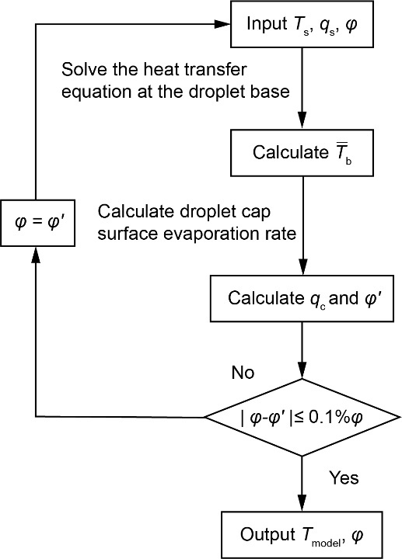

**Figure 4.** Algorithm for the droplet surface temperature and evaporation ratio

The algorithm for calculating the droplet surface temperature and the evaporation ratio is shown in Fig. 4. The base temperature of the substrate is tested by the thermocouple and the heat transfer rate from substrate is obtained by calculating the transient droplet volume decrease rate based on Eq. (5). An initial value (0.5) of the evaporation ratio which is defined as the ratio of evaporation rate from the droplet base surface and heat transfer rate in the micropillar in one unit cell is used to solve the heat transfer equation at the droplet base. The heat transfer equation Eq. (11) can be solved with knowing all the three boundary conditions. Thus, the temperature distribution at the droplet base surface Eq. (16) is obtained and the average temperature of the droplet base is calculated. Based on the one-dimensional conduction heat transfer model inside the water droplet, the nonuniform surface temperature distribution of the droplet can be solved. With knowing the droplet surface temperature distribution, the modified diffusion-driven heat transfer model with considering the nonuniform surface temperature is used to calculate the evaporation flux from the droplet cap surface. It is not practical to directly calculate the evaporation rate from the droplet base because of the complex structure of the micropillar in this investigation. The evaporation rate from the droplet base surface is calculate as the difference of the total evaporation rate and the evaporation rate from the droplet cap surface calculated by Eq. (25). The accuracy of the evaporation rate from the droplet base surface dependents on the accuracy of the calculating of evaporation rate from the droplet cap surface. It was calculated by Gleason and Putnam that the evaporation rate errors for droplet evaporation on 50 °C substrate and 65 °C substrate were 1.84% and 2.83%, respectively, with considering the surface temperature distribution. The small errors confirm that it is reasonable to predict the droplet cap surface evaporation rate with the surface temperature distribution based on the diffusion-driven model. Thus, the evaporation rate from the droplet cap surface is obtained and evaporation ratio can be obtained. After the iteration loop achieves convergence, the stable evaporation ratio and temperature distribution of the droplet cap surface are obtained. With knowing the temperature distribution of the droplet cap surface, the average temperature of the upper hemispherical surface of the droplet cap surface is calculated and compared with the experimental results for the validation of our thermal circuit model.

**4. Result and discussion**

**4.1. Droplet evaporation dynamics**

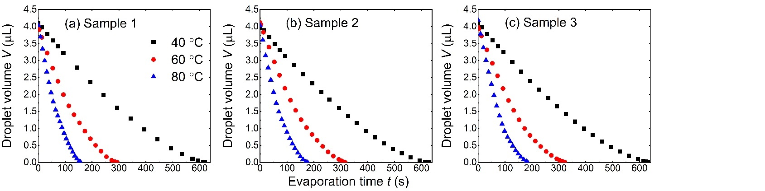

**Figure 5.** Temporal evolution of droplet volume on different substrates: (a) sample 1, (b) sample 2 and (c) sample 3. The substrate bases are heated to 40 °C, 60 °C and 80 °C.

The variation of droplet volume with respect to evaporation time on different substrates is shown in Fig. 5. Droplet volume decreases nonlinearly during the evaporation. The total evaporation time decreases with the rise of the substrate base temperature. The total evaporation time increases with the increase of the substrate periodicity when the substrate base temperature is kept the same. Droplet evaporation on sample 3 (60 μm periodicity) has the longest total evaporation time and on sample 1 (40 μm periodicity) has the shortest total evaporation time for the experiment with the same substrate base temperature. This increase of total evaporation time is credited to the increase of the thermal resistance between the droplet base and the substrate, which is caused by the increase of the substrate periodicity. The total evaporation time of droplet evaporation on different sample substrates is shown in Table 2.

**Table 2.** Total evaporation time for droplet on different substrates with different base temperature.

|  |  |  |
| --- | --- | --- |
| Substrate | Substrate base temperature (°C) | Total evaporation time (s) |
| Sample 1 | |  | | --- | | 40 | | 60 | | 80 | | |  | | --- | | 620.1 | | 293.3 | | 156.8 | |
| Sample 2 | |  | | --- | | 40 | | 60 | | 80 | | |  | | --- | | 627.1 | | 312.2 | | 177.1 | |
| Sample 3 | |  | | --- | | 40 | | 60 | | 80 | | |  | | --- | | 633.3 | | 322.3 | | 184.1 | |

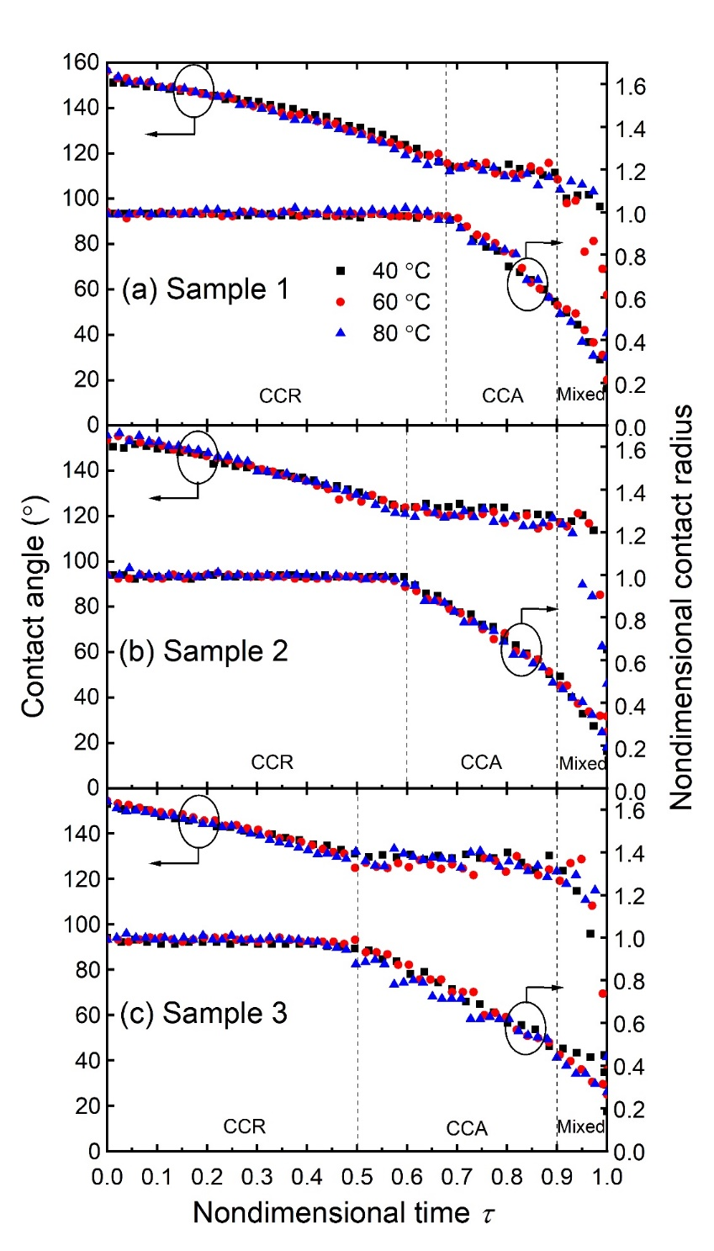

**Figure 6.** Evolution of droplet contact angle and nondimensional contact radius versus nondimensional time on different sample substrates: (a) sample 1, (b) sample 2 and (c) sample 3. The substrate bases are heated to 40 °C, 60 °C and 80 °C.

The variation of droplet contact angle and nondimensional contact radius with versus nondimensional time is shown in Fig. 6. Here the nondimensional contact radius is defined as the ratio of contact radius and the initial contact radius, and the nondimensional time is defined as the ratio of evaporation time and total evaporation time. It is observed from Fig. 6 that the variation of droplet transient contact angle and nondimensional contact radius is almost the same for droplet evaporation on substrate with different substrate base temperature. For droplet evaporation on sample 1 substrate (Fig. 6 (a)), the droplet contact angle decreases continuously in the first 68% part of the total evaporation time. During this period, the contact radius is kept unchanged. This is the constant contact radius mode for the droplet evaporation (CCR mode). After the contact angle reaches to the receding contact angle, the contact angle stops decreasing and keeps unchanged. Meanwhile, the contact radius starts to decrease. This is the constant contact angle mode for the droplet evaporation (CCA mode). The evaporation of droplet is in CCA mode till the nondimensional time approaches 0.9. Then, both the contact angle and contact radius decrease and this is the mixed mode for the droplet evaporation. For droplet evaporation on the same substrate with different substrate base temperatures, the evaporation process has almost the same compositions of the CCR mode, CCA mode and mixed mode. That means it is the substrate structure that affect the evaporation mode transition and the substrate temperature is not that important. The variations of droplet contact angle and nondimensional contact radius on sample 2 (Fig. 6(b)) and sample 3 (Fig. 6(c)) substrates are similar to the variation for droplet evaporation on sample 1. The receding contact angle increases with the increase of the periodicity of the substrate. The receding contact angles on sample 1, sample 2 and sample 3 are about 112°, 120° and 128° respectively. Since the initial contact angles of droplet on these three sample substrates are almost the same (about 155°), larger receding contact angle results in the shorter time of the CCR mode. The nondimensional evaporation times for CCR mode on sample 1, sample 2 and sample 3 are about 0.68, 0.6 and 0.5, respectively.

**4.2. Experimental and modeling droplet cap surface temperature**

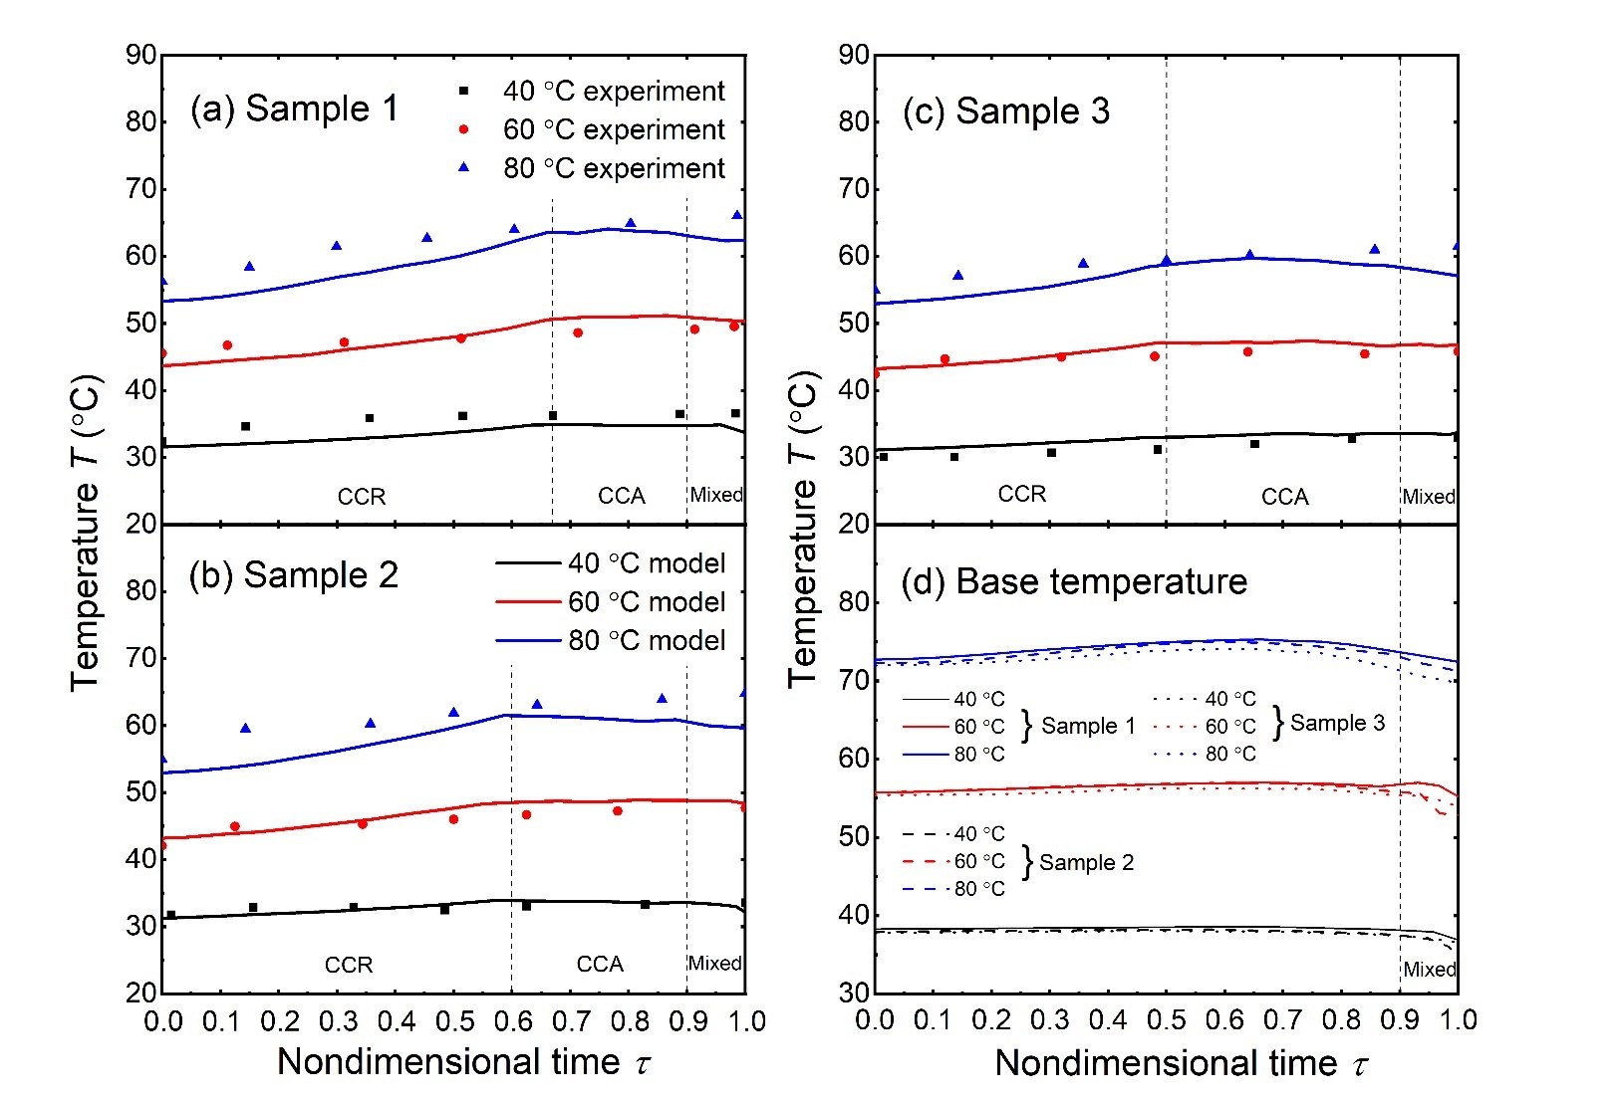

**Figure 7.** (a) Evolution of droplet cap surface temperature on sample 1 substrate. (b) Evolution of droplet cap surface temperature on sample 2 substrate. (c) Evolution of droplet cap surface temperature on sample 3 substrate. The solid lines represent the droplet cap surface temperature calculated by the thermal circuit model and the scatter dots are the experimental results tested by the IR camera. (d) Evolution of droplet base surface temperature on sample 1 sample 2 and sample 3 heated with base temperature 40 °C, 60 °C and 80°C.

In Fig. 7 (a), (b) and (c), we show the evolution of droplet cap surface temperature versus the nondimensional time. The droplet cap surface temperature calculated by the thermal circuit model matches well with the droplet cap surface temperature tested by the IR camera for the evaporation on substrates with substrate base temperature at 40 °C, 60 °C and 80 °C. There is a large temperature difference between the droplet cap surface and the substrate base temperature. This temperature difference is caused by the thermal resistances of the water droplet, the evaporation and the silicon substrate. It is observed that the surface temperature increases in the CCR mode and keeps essentially constant in the CCA mode. Same observation was also demonstrated by Saenz et al.[49] in their numerical simulation of droplet evaporation on heated surfaces. During the CCR mode, the volume of the droplet decreases and thermal resistance of the droplet decreases. The droplet cap surface gets closer to the substrate and thus the droplet cap surface temperature increases. In the CCA mode, the contact area between the droplet and the substrate decreases. As a result, less heat is transferred into the droplet, which hinders the temperature increase of the droplet. The combination effects of the decreasing contact area and decreasing water droplet thermal resistance result in the unchanged average surface temperature of the droplet cap surface. In the mixed mode, the droplet volume is very small (<0.05 μL), we don’t consider the droplet evaporation in the mixed mode in this discussion.

In Fig. 7 (d), we show that average temperature of the droplet base surface on different sample substrates and with different substrate base temperatures. We can find that there is an unneglectable temperature mismatch between the droplet base surface temperature and the substrate base temperature. Though there will be a temperature drop through the substrate because of the substrate thermal resistance, the large thermal conductivity of silicon (300 W/mK) means that the temperature drop caused by the silicon thermal resistance is small (< 1°C based on our calculating results). However, the temperature mismatches between the droplet base surface and the substrate base surface are about 2.5 °C, 4.4 °C and 7.5 °C on substrates with base temperature 40 °C, 60 °C and 80 °C. The main temperature difference between the droplet base surface and the substrate is caused by the evaporation from the droplet base surface.

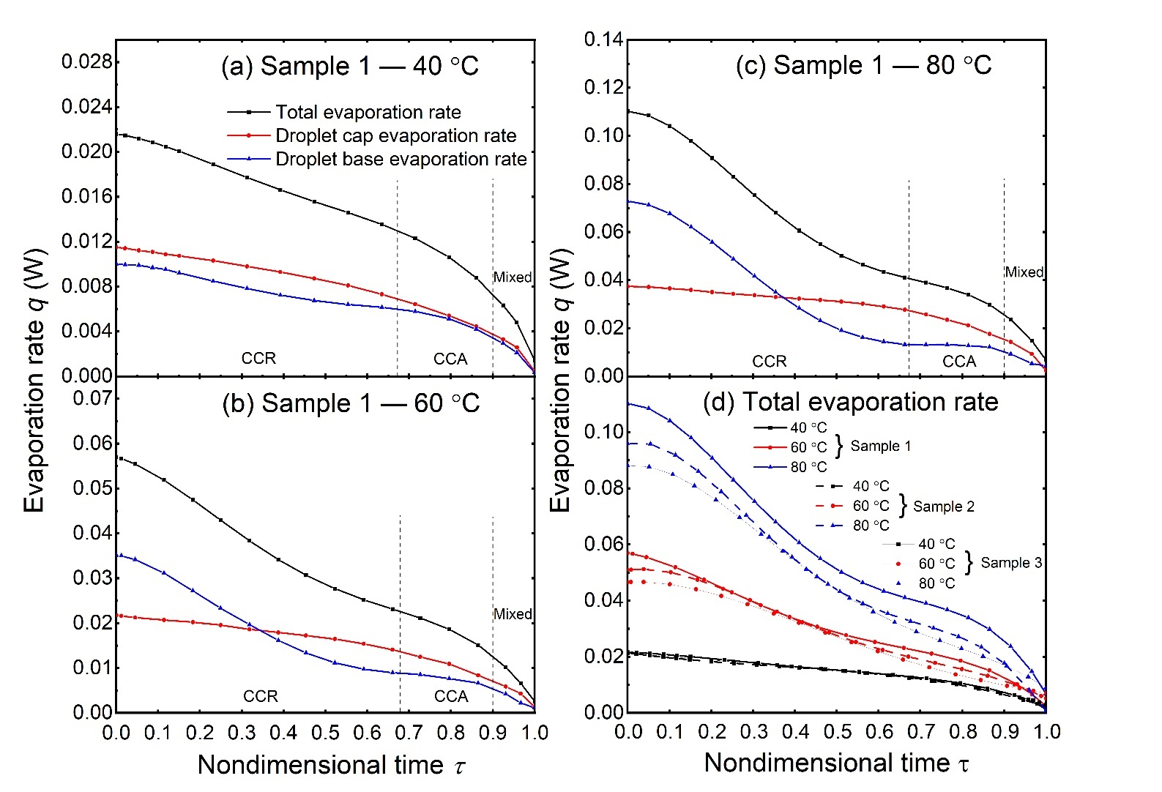

**Figure 8.** (a) Total evaporation rate, droplet cap surface evaporation rate and droplet base surface evaporation rate of droplet evaporation on sample 1 substrate with 40 °C substrate base temperature. (b) Total evaporation rate, droplet cap surface evaporation rate and droplet base surface evaporation rate of droplet evaporation on sample 1 substrate with 60 °C substrate base temperature. (c) Total evaporation rate, droplet cap surface evaporation rate and droplet base surface evaporation rate of droplet evaporation on sample 1 substrate with 80 °C substrate base temperature. (d) Total evaporation rate of droplet evaporation on sample 1, sample 2 and sample 3 substrates with substrate base temperature at 40 °C, 60 °C and 80 °C.

In Fig. 8 (a), (b) and (c), we show transient variation of the total evaporation rate, droplet cap surface evaporation rate and droplet base surface evaporation rate of droplet evaporation on sample 1 substrate with substrate base temperature at 40 °C, 60 °C and 80 °C. The evaporation rates of droplet on sample 2 and sample 3 substrates are given in the supporting information. The droplet total evaporation rate is calculated by the droplet volume decreasing rate with experimental transient droplet volume. The droplet cap surface evaporation rate is calculated by the diffusion driven model with considering the surface temperature distribution predicted by the thermal circuit model. The droplet base evaporation rate is the difference value of the total evaporation rate and the droplet cap surface evaporation rate. With the increase of the substrate base temperature (from 40 °C to 80 °C), both the evaporation rates from the droplet cap surface and droplet base surface temperature increase for a given nondimensional time. Also, both the evaporation rates from the droplet cap surface and the droplet base surface decrease during the droplet evaporation process for droplet evaporation on a substrate with a constant base temperature. It is observed that the decrease of the droplet cap surface evaporation rate in the CCR mode is very slow and the decrease of the droplet base surface evaporation rate in the CCA mode is slow. In the CCR mode, the decrease of the evaporation rate from the droplet cap surface is caused by the decrease of the droplet contact angle. The contact area between the droplet and the substrate keeps unchanged and the thermal resistances between the droplet base and the substrate are also unchanged. The decrease of the droplet total evaporation rate means that less heat is transferred from the substrate to the droplet. With the substrate base temperature and the thermal resistances between the droplet and substrate keep unchanged, the decrease of the total evaporation rate is caused by the decrease of the temperature difference between the droplet base surface and the substrate base surface. In other words, the decrease of the total evaporation rate will cause the increase of droplet base surface temperature, which is also shown in Fig. 11 (d). The increase of droplet base surface temperature will cause the increase of the droplet cap surface temperature which leads to the increase of the evaporation rate from the droplet cap surface temperature. The effect of droplet cap surface temperature increase mitigates the effect of the droplet contact angle decrease on the decrease of the evaporation rate from the droplet cap surface. The combination effects of the contact angle decrease, and the droplet cap surface temperature increase determine the slow decrease of the evaporation rate from droplet cap surface in the CCR mode. In the CCA mode, the average temperature of the droplet cap surface temperature keeps essentially constant which is different from increase trend of the cap surface temperature in the CCR mode. Meanwhile, the contact radius of the droplet decreases, which causes the decrease of heat transfer area between the droplet and the substrate. Thus, the evaporation rate of droplet cap surface decreases quickly. In summary, in CCR mode the decrease of the total evaporation rate of the droplet is mainly caused by the decrease of evaporation rate from the droplet base surface and in CCA mode, the decrease of the total evaporation rate is mainly caused by the decrease of the evaporation rate from the droplet cap surface.

Droplets evaporating on different substates exhibits different evaporation rate, as shown in Fig. 8 (d). Droplet evaporation on sample 1 (40 μm periodicity) substrate has the maximum evaporation rate and on sample 3 (60 μm periodicity) substrate has the minimum evaporation rate. Because of the different substrate periodicity, the solid-liquid interface areas are different for droplets evaporation on different sample substrates. Since droplets evaporation on different sample substrates have essentially the same apparent contact area (base area of the droplet), small substrate periodicity means larger heat transfer area between the droplet base and the substrate, i.e., the solid-liquid interface area. The larger solid-liquid interface area results in the higher droplet evaporation rate for evaporation with the same substrate base temperature.

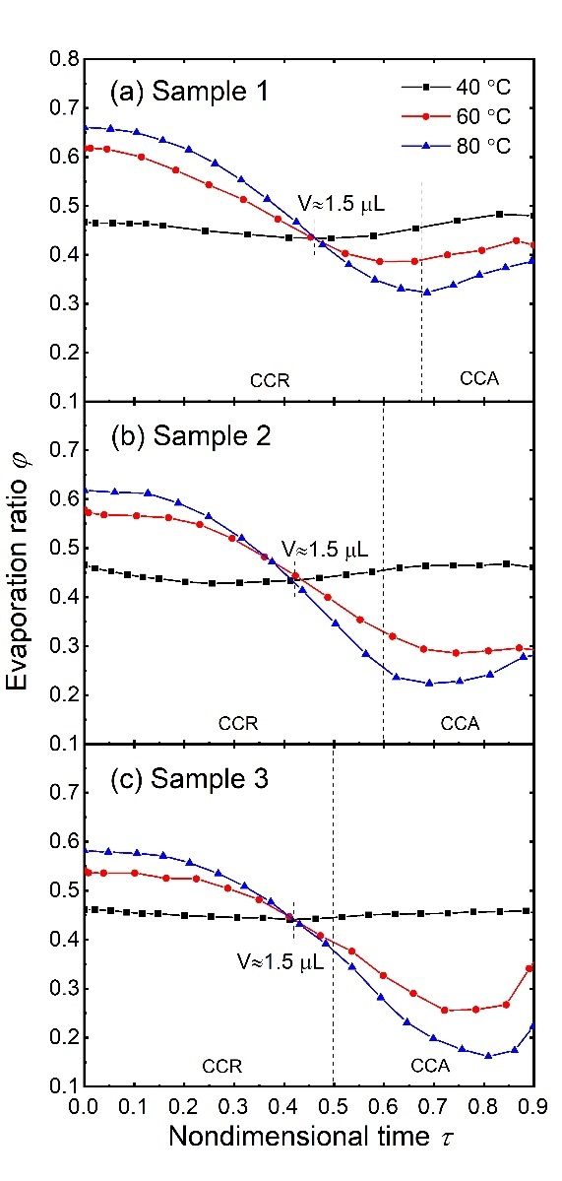

**Figure 9.** Evaporation ratio *φ* of droplet base surface with respect to nondimensional time on different sample substrates with different substrate base temperature.

The evaporation ratio of droplet base surface with respect to nondimensional time on different sample substrates with different substrate base temperatrure is shown in Fig. 9. Evaporation ratio *φ* is the ratio of evaporation rate from the droplet base surface and total evaporation ratio. It is observed that the evaporation ratio *φ* decreases in the CCR mode and increase in the last period of CCA mode. That is because of the difference decreasing rate of the evaporation ratio from the droplet cap surface and droplet base surface in the CCR mode and CCA mode. It has been discussed that the decrease of the total evaporation rate in CCR mode is mainly caused by the decrease of the evaporation ratio from the droplet base surface. The quick decrease of evaporation rate from the droplet base surface determines the decrease of the evaporation ratio in the CCR mode. In the CCA mode, the decrease from the droplet base surface is slow and the main decrease of the total evaporation rate is from the droplet cap surface. The slow decrease of the evaporation rate from the droplet base surface determines the increase of evaporation ratio. The evaporation ratio *φ* increases with the substrate temperature for droplet evaporation on the same substrate with large volume (larger than 1.5 μL). The increase of substrate temperature will cause a direct temperature increase of the droplet base surface and the temperature increase of the droplet base surface will then cause the temperature increase of the droplet cap surface. Due to the thermal resistance of the droplet bulk, the temperature increase of the droplet cap surface is smaller than that at the droplet base with the increase of the substrate temperature. Thus, the substrate temperature increase leads to a higher evaporation rate increase at the droplet base surface for large volume droplet. As a result, the evaporation ratio *φ* increase with the rise of the substrate temperature for droplet with large droplet volume. For droplets with small volume (smaller than 1.5 μL), the evaporation ratio *φ* decreases with the increase of the substrate temperature. Because of the small volume, the thermal resistance of the droplet bulk is small, and the increase of the substrate temperature will cause a higher temperature increase at droplet cap surface for droplets with small volume. Thus, the increase of the substrate temperature causes a higher evaporation rate increase than at the droplet base surface for droplets with smaller volume. As a result, the evaporation ratio *φ* decreases with rise of the substrate temperature for droplet with small volume.

**4.3. Effective conductivity of water for evaporation on high temperature substrate**

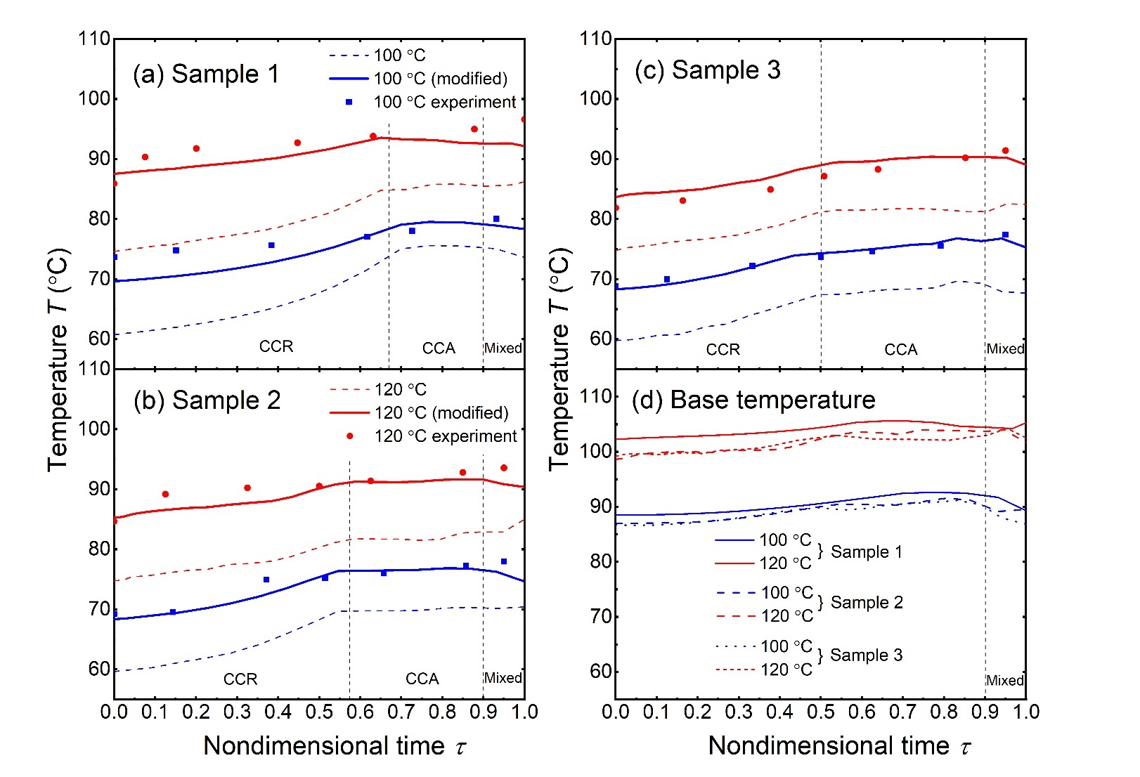

**Figure 10.** (a) Evolution of droplet cap surface temperature on sample 1 substrate. (b) Evolution of droplet cap surface temperature on sample 2 substrate. (c) Evolution of droplet cap surface temperature on sample 3 substrate. The dash lines represent the droplet cap surface temperatures calculated by the thermal circuit model, the solid lines represent the droplet cap surface temperatures modified with total average temperature and effective conductivity and the scatter dots are the experimental results tested by the IR camera. (d) Evolution of droplet base surface temperatures on sample 1 sample 2 and sample 3 heated with base temperature 100 °C and 120°C.

Fig. 10 (a), (b) and (c) show the droplet cap surface temperatures for droplet evaporation on different substrates with substrate temperature at 100 °C and 120 °C. The dash lines are the droplet cap surface temperatures calculated by the thermal circuit model. For droplet evaporation on substrate with relatively low temperatures (40 °C -80 °C), the droplet cap surface temperatures calculated by the thermal circuit model match well with the experimental results. However, for evaporation on high substrate base temperature, there are large derivations between the calculating results and the experimental results. These derivations are because that the fluid flow of the droplet is not taken into account in the thermal circuit model. For droplet evaporation on substrate with substrate base temperature from 40 °C to 80 °C, the effects of droplet flow in the droplet are not significant for the droplet cap surface temperature. As mentioned by Dash and Garimella, the characteristic velocity of fluid in a 3 μL water droplet evaporation on 40 °C - 60 °C substrates is of tens of microns per second and the Peclet number is less than 1. Thus, it is reasonable to only consider the conduction heat transfer and neglect the internal convection of the water droplet when calculating the droplet cap surface temperature in this investigation for relatively low substrate base temperatures (40 °C -80 °C). With the increase of the substrate base temperature, more heat is transferred through the droplet and the temperature difference between the droplet top and bottom surface becomes larger. Fluid motion driven by the temperature gradient in the droplet becomes violent and the characteristic velocity of the fluid in the droplet increases. Thus, we need to consider the effects of the fluid motion inside the droplet in the thermal circuit model when calculating the droplet cap surface temperature.

In this study, the IR camera is placed on the top side of the droplet normal to the substrate and the experimental result temperature tested by the IR camera is understood as the average temperature of the upper hemispherical surface of the droplet. Correspondingly, the average temperature of the droplet upper hemispherical surface is calculated and compared with the experimental data. The droplet internal flow will mitigate the temperature difference between the droplet top and bottom surface and the temperature tested by the IR camera becomes higher than the calculating results with only considering the conduction heat transfer as shown in Fig. 10. To consider effects of the droplet internal flow on the droplet surface temperature in the thermal circuit model, we calculate the overall average temperature of the droplet cap surface instead of only the upper hemispherical surface as the model predicted surface temperature as the solid lines shown in Fig. 13 (a), (b) and (c). The modified calculating temperature results match well with the experimental data for droplet evaporation on sample 1, 2 and 3 with substrate base temperature at 100 °C as shown in Fig. 10 (a), (b) and (c).

But there are still large derivations between the results for droplet evaporation on substrates with base temperature at 120 °C. The effects of convection heat transfer in the water droplet cannot be neglected. In the thermal circuit model, droplet is discretized into layers and only the conductive thermal resistances are calculated when calculating the droplet surface temperature. Convection in the water droplet will enhance the heat transfer in the droplet and reduce the total thermal resistances of the water droplet. Because of the complexity of internal flow, it is not practical to analyze the convection heat transfer base on the droplet velocity. Alternatively, an effective value of the water thermal conductivity is used to consider the heat transfer of both the convection and conduction. An effective conductivity is defined as:

(28)

where *e* is a coefficient of the effective conductivity.

The effective conductivity is used in the thermal circuit model in replace of the original water conductivity to consider the both the conduction and the convection heat transfer in the droplet. The coefficient of the effective conductivity *e* is larger than 1 which means the effects of convection heat transfer is equivalent as conduction heat transfer and all the effects of conduction heat transfer are added together. The minimum value of *e* that allows the average absolute difference between the model predicted surface temperature and the experimental temperature less than 2 °C is chosen as the coefficient of the effective conductivity:

(29)

The coefficient for the effective thermal conductivity for droplet evaporation on sample 1, 2 and 3 at 120 °C substrate base temperature is about 3.2, 2.9 and 2.7, respectively. Our results of coefficient are close to the numerical fitting coefficient 2.72 obtained Abramzon and Sirignano[50].

The substrates are heated to a high temperature over the boiling temperature of the water droplet. However, no water boiling is observed in the droplet even when the substrate temperature is about 120 °C. That is because of the effect of evaporative cooling at the droplet base. Evaporation at the droplet base surface will cool down the surface temperature and we calculate the average temperature of the droplet base surface as shown in Fig. 13 (d). For droplet evaporation on 100 °C substrate, the base surface temperature is about 88 °C and for droplet evaporation on 120 °C substrate, the base surface temperature is about 102 °C which is very close to 100 °C. Our results show that the evaporation from the droplet base surface can significantly cool down the attached solid surface and delay the onset of droplet boiling with the rise of substrate base temperature.

**5. Conclusions**

In this paper, the evaporation dynamics of solitary water droplet on hot micro-structured superhydrophobic surfaces have been experimentally and theoretically investigated. Most previous investigations of sessile droplet evaporation were carried out at room temperature (20 °C – 30 °C) while the effects of the temperature were ignored[28-31]. Studies about the effects of substrate temperature on the sessile droplet evaporation mainly focused on the droplet Leidenfrost effects[38, 39, 51] in which the droplet is levitated by the evaporating vapor with a very high temperature substrate (200 °C – 300 °C). Only a few studies investigated the sessile droplet evaporation dynamics on hot substrate with relative low temperature (40 °C – 100 °C) and very limited attention has been paid to the evaporation from the droplet base surface whose contribution is amplified by the increase of the substrate temperature. Here, for the first time, we conducted a comprehensive thermal resistance analysis for the sessile droplet evaporation on hot micro-structured superhydrophobic substrates to analyze evaporation of droplet from droplet cap surface and droplet base surface, respectively.

According to our theoretical analysis, it is found that droplet cap surface temperature shows different trends in different evaporation modes, i.e., droplet cap surface temperature increases in the CCR mode and keeps essentially constant in the CCA mode. The total evaporation rate of the droplet decreases during the evaporation process. In the CCR mode the decrease of the total evaporation rate of the droplet is mainly caused by the decrease of evaporation rate from the droplet base surface and in the CCA mode the decrease of the total evaporation rate is mainly caused by the decrease of the evaporation rate from the droplet cap surface. The evaporation ratio 𝜑 decreases in the CCR mode and increases approaches the end of CCA mode. For droplet volume larger than 1.5 μL, 𝜑 increases with the rise of the substrate temperature and for small droplet volume 𝜑 decreases with the rise of the substrate temperature. Internal fluid motion affects the droplet evaporation process on substrates with high temperatures (100 °C- 120 °C) and an effective thermal conductivity , which is about three times of water conductivity , is employed as a correction factor for the thermal circuit model to consider the effect of convection heat transfer in the water droplet. The average temperatures of the droplet base surfaces are calculated and large temperature difference between the droplet base are observed. The temperature differences between the droplet base and substrate base are about 2 °C, 5 °C, 8 °C, 12.5 °C and 18 °C for the sessile droplet evaporation on substrate with base temperature at 40 °C, 60 °C, 80 °C, 100 °C, and 120 °C, respectively.

Our investigation about the sessile droplet evaporation on hot micro-structured superhydrophobic surface can deepen our understanding about the heat and mass transfer behavior of the droplet evaporation process. Meanwhile this thermal circuit model provides us a convenient tool to describe the evaporation dynamics for the sessile droplet on hot micro-structured substrates.

**6. CRediT authorship contribution statement**

†W.H. and X.H. are co-first authors with equal contribution to this work. W.H., X.H and J.C. conceived the research idea. W.H. designed and carried out the experiments, W.H. and X.H. conducted the theoretical analysis. Y.L. fabricated the devices. W.H., X.H. and J.C. wrote the manuscript. Y.L. edited the manuscript. [2]

**7. Declaration of Competing Interest**

None.

**8. Acknowledgment**

This work is financially supported by NSF CBET under grant number 1550299 and NSF ECCS under grant

**9. Reference**

[1]. P. Calvert, Inkjet Printing for Materials and Devices, Chem. Mater., 13 (10) (2001) 3299-3305.

[2]. H.-m. Kwon, J.C. Bird, and K.K. Varanasi, Increasing Leidenfrost point using micro-nano hierarchical surface structures, Applied Physics Letters, 103 (20) (2013)

[3]. A. Wu, L. Yu, Z. Li, H. Yang, and E. Wang, Atomic force microscope investigation of large-circle DNA molecules, Anal Biochem, 325 (2) (2004) 293-300.

[4]. W. Jia and H.H. Qiu, Experimental investigation of droplet dynamics and heat transfer in spray cooling, Exp. Therm. Fluid Sci., 27 (7) (2003) 829-838.

[5]. J. Song, W. Cheng, M. Nie, X. He, W. Nam, J. Cheng, and W. Zhou, Partial Leidenfrost Evaporation-Assisted Ultrasensitive Surface-Enhanced Raman Spectroscopy in a Janus Water Droplet on Hierarchical Plasmonic Micro-/Nanostructures, ACS Nano, 14 (8) (2020) 9521-9531.

[6]. S.A. Putnam, A.M. Briones, L.W. Byrd, J.S. Ervin, M.S. Hanchak, A. White, and J.G. Jones, Microdroplet evaporation on superheated surfaces, International Journal of Heat and Mass Transfer, 55 (21) (2012) 5793-5807.

[7]. P. Tsai, R.G. Lammertink, M. Wessling, and D. Lohse, Evaporation-triggered wetting transition for water droplets upon hydrophobic microstructures, Physical review letters, 104 (11) (2010) 116102.

[8]. L. Zhao and J. Cheng, Analyzing the Molecular Kinetics of Water Spreading on Hydrophobic Surfaces via Molecular Dynamics Simulation, Scientific Reports, 7 (1) (2017) 10880.

[9]. L. Zhao and J. Cheng, The mechanism and universal scaling law of the contact line friction for the Cassie-state droplets on nanostructured ultrahydrophobic surfaces, Nanoscale, 10 (14) (2018) 6426-6436.

[10]. X. He, L. Zhao, and J. Cheng, Coalescence-Induced Swift Jumping of Nanodroplets on Curved Surfaces, Langmuir, 35 (30) (2019) 9979-9987.

[11]. L.S. Lam, M. Hodes, and R. Enright, Analysis of Galinstan-Based Microgap Cooling Enhancement Using Structured Surfaces, Journal of Heat Transfer, 137 (9) (2015)

[12]. A. Al-Sharafi, B.S. Yilbas, and H. Ali, Droplet Heat Transfer on Micropost Arrays With Hydrophobic and Hydrophilic Characteristics, Journal of Heat Transfer, 140 (7) (2018)

[13]. C.-C. Hsu, Y.-A. Lee, C.-H. Wu, and C.S.S. Kumar, Self-propelled sessile droplets on a superheated and heterogeneous wetting surface, Colloids and Surfaces A: Physicochemical and Engineering Aspects, 612 (2021)

[14]. F.G.H. Schofield, S.K. Wilson, D. Pritchard, and K. Sefiane, The lifetimes of evaporating sessile droplets are significantly extended by strong thermal effects, Journal of Fluid Mechanics, 851 (2018) 231-244.

[15]. B. Sobac and D. Brutin, Thermal effects of the substrate on water droplet evaporation, Phys Rev E 86 (2 Pt 1) (2012) 021602.

[16]. K. Gleason, H. Voota, and S.A. Putnam, Steady-state droplet evaporation: Contact angle influence on the evaporation efficiency, International Journal of Heat and Mass Transfer, 101 (2016) 418-426.

[17]. S. Adera, R. Raj, R. Enright, and E.N. Wang, Non-wetting droplets on hot superhydrophilic surfaces, Nat. Commun., 4 (2013) 2518.

[18]. R. Hays, D. Maynes, and J. Crockett, Thermal transport to droplets on heated superhydrophobic substrates, Int. J. Heat Mass Transfer, 98 (2016) 70-80.

[19]. M.S. Hanchak, A.M. Briones, J.S. Ervin, and L.W. Byrd, One-dimensional models of nanoliter droplet evaporation from a hot surface in the transition regime, International Journal of Heat and Mass Transfer, 57 (2) (2013) 473-483.

[20]. S.Y. Misyura, Contact angle and droplet heat transfer during evaporation on structured and smooth surfaces of heated wall, Applied Surface Science, 414 (2017) 188-196.

[21]. M.A. Kadhim, N. Kapur, J.L. Summers, and H. Thompson, Experimental and Theoretical Investigation of Droplet Evaporation on Heated Hydrophilic and Hydrophobic Surfaces, Langmuir, 35 (19) (2019) 6256-6266.

[22]. L. Liu, X. Liang, X. Wang, S. Kong, K. Zhang, and M. Mi, Evaporation of a sessile water droplet during depressurization, International Journal of Thermal Sciences, 159 (2021) 106587.

[23]. L. Bansal, S. Chakraborty, and S. Basu, Confinement-induced alterations in the evaporation dynamics of sessile droplets, Soft Matter, 13 (5) (2017) 969-977.

[24]. S. Semenov, F. Carle, M. Medale, and D. Brutin, Boundary conditions for a one-sided numerical model of evaporative instabilities in sessile drops of ethanol on heated substrates, Phys Rev E, 96 (6-1) (2017) 063113.

[25]. R.G. Picknett and R. Bexon, The evaporation of sessile or pendant drops in still air, Journal of Colloid and Interface Science, 61 (2) (1977) 336-350.

[26]. M.E.R. Shanahan, Simple Theory of "Stick-Slip" Wetting Hysteresis, Langmuir, 11 (3) (1995) 1041-1043.

[27]. N.N. Lebedev, Special Functions and Their Applications. Prentice-Hall. Englewood Cliffs, NJ, USA. 1965.

[28]. R.G.L. Hua Hu, Evaporation of a Sessile droplet on a substrate, J Phys Chem B, 106 (2002) 1334-1344.

[29]. O.B. Robert D. Deegan, Todd F. Dupont, Greg Huber, Sidney R. Nagel, and Thomas A. Witten, Contact line deposits in an evaporating drop, Phys Rev E, 62 (2000)

[30]. Y.O. Popov, Evaporative deposition patterns: spatial dimensions of the deposit, Phys. Rev. E 71 (3) (2005) 1-17.

[31]. T.A.H. Nguyen, A.V. Nguyen, M.A. Hampton, Z.P. Xu, L. Huang, and V. Rudolph, Theoretical and experimental analysis of droplet evaporation on solid surfaces, Chemical Engineering Science, 69 (1) (2012) 522-529.

[32]. H. Gelderblom, Á.G. Marín, H. Nair, A. van Houselt, L. Lefferts, J.H. Snoeijer, and D. Lohse, How water droplets evaporate on a superhydrophobic substrate, Physical Review E, 83 (2) (2011) 026306.

[33]. S. Dash and S.V. Garimella, Droplet evaporation dynamics on a superhydrophobic surface with negligible hysteresis, Langmuir, 29 (34) (2013) 10785-95.

[34]. A. Aldhaleai, F. Khan, T. Thundat, and P.A. Tsai, Evaporation dynamics of water droplets on superhydrophobic nanograss surfaces, International Journal of Heat and Mass Transfer, 160 (2020)

[35]. S. Dash and S.V. Garimella, Droplet evaporation on heated hydrophobic and superhydrophobic surfaces, Phys Rev E, 89 (2014) 042402.

[36]. G. McHale, S. Aqil, N.J. Shirtcliffe, M.I. Newton, and H.Y. Erbil, Analysis of droplet evaporation on a superhydrophobic surface, Langmuir, 21 (2005) 11053-11060.

[37]. J.M. Stauber, S.K. Wilson, B.R. Duffy, and K. Sefiane, Evaporation of droplets on strongly hydrophobic substrates, Langmuir, 31 (12) (2015) 3653-60.

[38]. M. Wei, Y. Song, Y. Zhu, D.J. Preston, C.S. Tan, and E.N. Wang, Heat transfer suppression by suspended droplets on microstructured surfaces, Applied Physics Letters, 116 (23) (2020)

[39]. S.H. Kim, H. Seon Ahn, J. Kim, M. Kaviany, and M. Hwan Kim, Dynamics of water droplet on a heated nanotubes surface, Applied Physics Letters, 102 (23) (2013)

[40]. J. Cheng, A. Vandadi, and C.-L. Chen, Condensation heat transfer on two-tier superhydrophobic surfaces, Appl. Phys. Lett., 101 (13) (2012)

[41]. A. Vandadi, L. Zhao, and J. Cheng, Resistant energy analysis of self-pulling process during dropwise condensation on superhydrophobic surfaces, Nanoscale Adv., 1 (3) (2019) 1136-1147.

[42]. X. Liu, P.R. Coxon, M. Peters, B. Hoex, J.M. Cole, and D.J. Fray, Black silicon: fabrication methods, properties and solar energy applications, Energy & Environmental Science, 7 (10) (2014) 3223-3263.

[43]. M. Badv, I.H. Jaffer, J.I. Weitz, and T.F. Didar, An omniphobic lubricant-infused coating produced by chemical vapor deposition of hydrophobic organosilanes attenuates clotting on catheter surfaces, Sci. Rep., 7 (1) (2017) 11639.

[44]. M. di Marzo and D.D. Evans, Evaporation of a water droplet deposited on a hot high thermal conductivity solid surface, (PB--86-247871/XAB) (1986) 34.

[45]. K.M. Itaru Michiyoshe, Heat transfer characteristics of evaporation of a liquid droplet on heated surfaces, international Journal of Heat and Mass Transfer, 21 (1977) 605-613.

[46]. M. Seki, H. Kawamura, and K. Sanokawa, Transient temperature profile of a hot wall due to an impinging liquid droplet, Journal of Heat Transfer, 100 (1987) 167-169.

[47]. Seri Lee, Seaho Song, Van Au, and K.P. Moran. Constriction Spreading resistance model for electroics packing. in ASME/JSME Thermal Engineering Conference. 1995.

[48]. D.P. Kennedy, Spreading Resistance in Cylindrical Semiconductor Devices, Journal of Applied Physics, 31 (8) (1960) 1490-1497.

[49]. P.J. Sáenz, K. Sefiane, J. Kim, O.K. Matar, and P. Valluri, Evaporation of sessile drops: a three-dimensional approach, Journal of Fluid Mechanics, 772 (2015) 705-739.

[50]. W.A.S. B. Abrambon, Droplet vaporization model for spray combusition calculations, International Journal of Heat and Mass Transfer, 32 (1989) 1605-1618.

[51]. D.A. del Cerro, A.G. Marin, G.R. Romer, B. Pathiraj, D. Lohse, and A.J. Huis in 't Veld, Leidenfrost point reduction on micropatterned metallic surfaces, Langmuir, 28 (42) (2012) 15106-10.